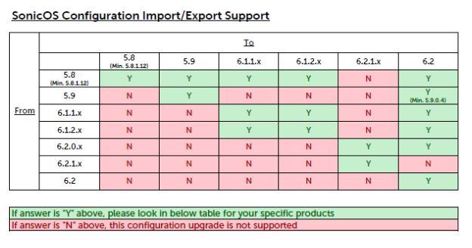

Source: Sonicwall NSA 3600 OSv6.1.1.9

Target: Sonicwall NSA 4600 OSv6.1.1.9-30n

1. Connect your PC to the Mgmt Port
2. Set your PC IP to XXX.XXX.XXX.XXX
3. Go to http:// XXX.XXX.XXX.XXX
4. Being the installation wizard and set the IP for X0-LAN a static IP to a dummy subnet (example XXX.XXX.XXX.XXX) and the X1-WAN with a static IP within your LAN subnet (example XXX.XXX.XXX.XXX/<CDIR>)
5. Disconnect from the Mgmt. Port
6. Connect the NSA 4600 to your LAN using port x0 and change your pc IP to XXX.XXX.XXX.XXX
7. Go to https:// XXX.XXX.XXX.XXX
8. Login
9. Click on “Register”

https:// XXX.XXX.XXX.XXX/uploadNew.html#

To manually register, note the following information:

Serial Number:

Authentication Code:

To import see https://support.sonicwall.com/kb/sw3858

Network config for production

X1

WAN

Static

IP XXX.XXX.XXX.XXX

255.255.255.0

Gateway XXX.XXX.XXX.XXX

DNS1 XXX.XXX.XXX.XXX

DNS2 XXX.XXX.XXX.XXX

DNS3 XXX.XXX.XXX.XXX

Comment

Mgmt

Userlogin

Checked Add rule to enable redirect

X0

XXX.XXX.XXX.XXX

XXX.XXX.XXX.XXX